

**KIRAN’S GYM**

**DBMS PROJECT REPORT**

By:

Greeshma Karanth  
PES1201700407  
4-D

Shivangi Gupta  
PES1201700274  
4-0044

Niharika Pentapati  
PES1201700215  
4-D

**PROBLEM STATEMENT**

**Kiran’s Gym** is a new and upcoming gym. Every member who enrols gets a personal instructor to train them. Instructors, or trainers, conduct exercises for the members according to their requirements, using the state-of-the-art equipment available in the gym. Each member can take up a combination of one or more of the many different exercises offered as contained in the subscription packs. Official gym merchandise is given to the instructors on joining and is available for members to purchase. Visit us at our official website to join today!

**OBJECTIVE**

Being fit and healthy is very important. To emphasise the importance of healthcare and fitness, we have built this example of a real-life gym. Our website allows people to sign up and choose their subscription packs or log in and check their schedules. This is done with the help of the vast database that we have developed and some back-end linking of the website to the database. The database contains all relevant information about the members, trainers, exercises, equipment, subscription packs and merchandise. The website also gives information about the gym as well as displays the merchandise available for purchase there. Effectively, we are using this website as a means to motivate people to care more for their body and stay stronger for longer.

**LIMITATIONS**

We have tried to capture all relevant data in the database for future purposes. But, the amount of information at hand is never enough. We can try to add more fields and tables to gather all required data. We can further try to eliminate all redundant data and tables. As far as a website goes, we have tried to come up with a fully functional prototype. However, it can be improved by providing online purchasing of merchandise and other convenient adaptations.

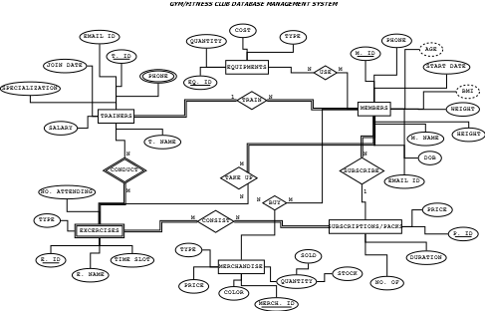**ER DIAGRAM**

**RELATIONAL MODEL**

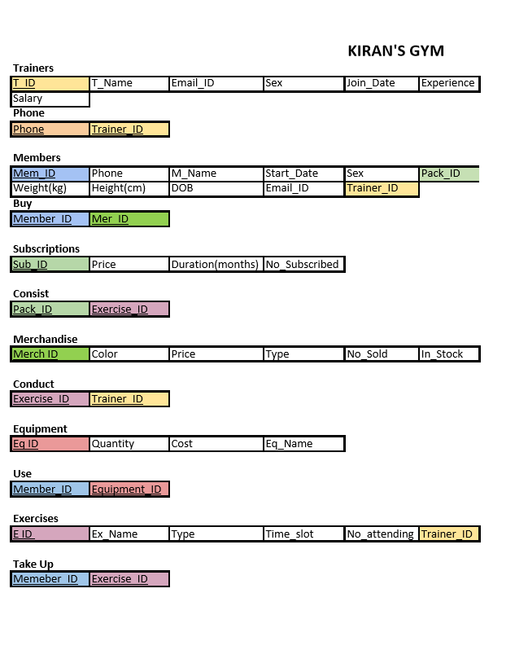

**SQL CODE FOR CREATE TABLE**

\c postgres

DROP DATABASE newgym;

CREATE DATABASE newgym;

\c newgym

CREATE TABLE Trainers(

T_ID char(15) PRIMARY KEY,

T_Name varchar(20) NOT NULL,

Email_ID varchar NOT NULL UNIQUE,

Sex CHAR,

Join_Date date NOT NULL,

Experience_in_Years int,

Salary decimal(7,2)

);

CREATE TABLE Phone(

Phone_no varchar(10) NOT NULL,

Trainer_ID char(15) NOT NULL,

PRIMARY KEY (Phone_no, Trainer_ID),

FOREIGN KEY (Trainer_ID) REFERENCES Trainers(T_ID) on delete cascade

);

CREATE TABLE Subscriptions(

Sub_ID char(15) PRIMARY KEY,

Price int NOT NULL,

Duration_in_Months int NOT NULL,

No_Subscribed int

);

CREATE TABLE Members(

Mem_ID char(15) PRIMARY KEY,

Phone varchar(10) NOT NULL,

M_Name varchar(20) NOT NULL,

Start_Date date NOT NULL,

Sex char,

Weight_in_kg decimal(3,1),

Height_in_cm decimal(4,1),

Date_Of_Birth date NOT NULL,

Email_ID varchar NOT NULL UNIQUE,

Pack_ID char(15),

End_Date date NOT NULL,

Trainer_ID char(15),

FOREIGN KEY (Pack_ID) REFERENCES Subscriptions (Sub_ID) on delete no action,

FOREIGN KEY (Trainer_ID) REFERENCES Trainers(T_ID) on delete set null);

CREATE TABLE Merchandise(

Merch_ID char(15) PRIMARY KEY,

Color varchar(10) NOT NULL,

Price int NOT NULL,

Type varchar(10),

No_Sold int,

No_In_Stock int

);

CREATE TABLE Exercises(

E_ID char(15) PRIMARY KEY,

Ex_Name varchar(20) NOT NULL,

Type varchar(15),

Time_Slot time,

No_Attending int,

Trainer_ID char(15),

FOREIGN KEY (Trainer_ID) REFERENCES Trainers (T_ID) on delete cascade);

CREATE TABLE Equipments(

Eq_ID char(15) PRIMARY KEY,

Quantity int,

Cost int,

Eq_Name varchar(15) NOT NULL);

CREATE TABLE Consist(

Pack_ID char(15),

Exercise_ID char(15),

PRIMARY KEY (Pack_ID, Exercise_ID),

FOREIGN KEY (Pack_ID) REFERENCES Subscriptions(Sub_ID) on delete cascade,

FOREIGN KEY (Exercise_ID) REFERENCES Exercises (E_ID) on delete cascade);

CREATE TABLE Buy(

Member_ID char(15),

Mer_ID char(15),

PRIMARY KEY(Member_ID, Mer_ID),

FOREIGN KEY (Member_ID) REFERENCES Members(Mem_ID) on delete cascade,

FOREIGN KEY (Mer_ID) REFERENCES Merchandise(Merch_ID) on delete cascade);

CREATE TABLE Conduct(

Exercise_ID char(15),

Trainer_ID char(15),

PRIMARY KEY(Exercise_ID, Trainer_ID),

FOREIGN KEY (Exercise_ID) REFERENCES Exercises(E_ID) on delete cascade,

FOREIGN KEY (Trainer_ID) REFERENCES Trainers(T_ID) on delete cascade

);

CREATE TABLE Use(

Member_ID char(15),

Equipment_ID char(15),

PRIMARY KEY(Member_ID, Equipment_ID),

FOREIGN KEY (Member_ID) REFERENCES Members (Mem_ID) on delete cascade,

FOREIGN KEY (Equipment_ID) REFERENCES Equipments (Eq_ID) on delete cascade

);

CREATE TABLE Takeup(

Member_ID char(15),

Excercise_ID char(15),

PRIMARY KEY(Member_ID, Excercise_ID),

FOREIGN KEY (Member_ID) REFERENCES Members (Mem_ID) on delete cascade,

FOREIGN KEY (Excercise_ID) REFERENCES Exercises(E_ID) on delete cascade

);

ALTER TABLE MEMBERS add check(phone between '6000000000' and '9999999999');

**SQL CODE FOR INSERT TABLE**

delete from Trainers;

delete from Phone;

delete from Subscriptions;

delete from Members;

delete from Merchandise;

delete from Exercises;

delete from Equipments;

delete from Consist;

delete from Buy;

delete from Conduct;

delete from Use;

delete from Takeup;

INSERT into Trainers values('T001', 'Rajesh Khanna', 'rajesh@kiransgym.com','M','12-08-2008',12,60000);

INSERT into Trainers values('T002', 'Ram Krishna', 'ram@kiransgym.com','M','21-10-2009',5,50000);

INSERT into Trainers values('T003', 'Sanjana Kumar', 'sanjana@kiransgym.com','F','2-01-2007',9,55000);

INSERT into Trainers values('T004','Nikhil Shetty','nikhil@kiransgym.com','M','3-03-2008',7,65000);

INSERT into Trainers values('T005','Ananya Kapoor','ananya@kiransgym.com','F','10-11-2010',6,45000);

INSERT into Phone values('9901231175', 'T001');

INSERT into Phone values('8193556722', 'T002');

INSERT into Phone values('9743566721', 'T003');

INSERT into Phone values('9900886745', 'T004');

INSERT into Phone values('7689455889', 'T005');

INSERT into Subscriptions values('SP02', 16000, 6, 71);

INSERT into Subscriptions values('SP01', 9000, 3, 87);

INSERT into Subscriptions values('SP05', 30000, 12, 42);

INSERT into Subscriptions values('SP04', 10100, 8, 53);

INSERT into Subscriptions values('SP03', 8900, 7, 35);

INSERT into Members values('M0012', '9987760552', 'Mythali Saxena', '3-06-2012', 'F', 63, 156, '15-05-1982', 'mythalisaxena15@gmail.com', 'SP03', '02-06-2013', 'T002');

INSERT into Members values('M0035', '9784567732', 'Navneet Singhania', '17-11-2015', 'M', 80.0, 170, '09-11-1988', 'navneet_singhania@gmail.com', 'SP01', '16-05-2016', 'T003');

INSERT into Members values('M0189', '8655745233', 'Rashmi Anand', '24-12-2018', 'F', 63, 159, '4-3-1991', 'rashmi43@gmail.com', 'SP02', '23-03-2019', 'T001');

INSERT into Members values('M0112', '9088781572', 'Robert Thapar', '3-03-2019', 'M', 86, 186, '15-05-1989', 'robertthapar@gmail.com', 'SP04','2-11-2020' , 'T002');

INSERT into Members values('M0352', '9824564532', 'Josh Khanna', '17-02-2019', 'M', 85.0, 176, '09-11-1987', 'joshkhanna@gmail.com', 'SP02','16-05-2019', 'T001');

INSERT into Members values('M0089', '8155766633', 'Seetha Ram', '24-01-2019', 'F', 69, 158, '4-3-1992', 'ramseetha@gmail.com', 'SP01', '23-07-2019','T003');

INSERT into Merchandise values('01RED', 'Red', 200, 'Headband', 50, 5);

INSERT into Merchandise values('01BLU', 'Blue', 200, 'Headband', 60, 45);

INSERT into Merchandise values('01GRE', 'Green', 200, 'Headband', 42, 63);

INSERT into Merchandise values('02RED', 'Red', 800, 'Tee', 98, 52);

INSERT into Merchandise values('02BLU', 'Blue', 800, 'Tee', 109, 4);

INSERT into Merchandise values('03GRE', 'Green', 900, 'Shorts', 46, 34);

INSERT into Exercises values('EX01', 'Aerobics', 'Endurance', '1:00:00', 58, 'T001');

INSERT into Exercises values('EX02', 'S&C', 'Strength', '15:00:00', 36, 'T003');

INSERT into Exercises values('EX03', 'HRX', 'High Intensity', '18:00:00', 44, 'T002');

INSERT into Exercises values('EX04', 'Balance Training', 'Balance', '14:00:00', 34, 'T004');

INSERT into Exercises values('EX05', 'Stretches', 'Flexibilty', '07:00:00', 36, 'T005');

INSERT into Equipments values('EQ01', 10, 3250, 'Treadmill');

INSERT into Equipments values('EQ02', 8, 1050, 'Medicine Ball');

INSERT into Equipments values('EQ03', 16, 1700, 'Weights');

INSERT into Equipments values('EQ04', 19, 1350, 'Dumb Bells');

INSERT into Equipments values('EQ05', 7, 9000, 'Squat Rack');

INSERT into Consist values('SP01', 'EX01');

INSERT into Consist values('SP01', 'EX02');

INSERT into Consist values('SP02', 'EX01');

INSERT into Consist values('SP02', 'EX02');

INSERT into Consist values('SP02', 'EX04');

INSERT into Consist values('SP03', 'EX02');

INSERT into Consist values('SP05', 'EX04');

INSERT into Consist values('SP05', 'EX03');

INSERT into Consist values('SP05', 'EX02');

INSERT into Consist values('SP05', 'EX01');

INSERT into Consist values('SP04', 'EX05');

INSERT into Consist values('SP04', 'EX03');

INSERT into Buy values('M0012', '01BLU');

INSERT into Buy values('M0035', '02BLU');

INSERT into Buy values('M0189', '01RED');

INSERT into Buy values('M0352', '03GRE');

INSERT into Buy values('M0089', '02RED');

INSERT into Conduct values('EX01', 'T001');

INSERT into Conduct values('EX02', 'T003');

INSERT into Conduct values('EX03', 'T002');

INSERT into Conduct values('EX04', 'T005');

INSERT into Conduct values('EX05', 'T004');

INSERT into Use values('M0012', 'EQ02');

INSERT into Use values('M0189', 'EQ03');

INSERT into Use values('M0035', 'EQ01');

INSERT into Use values('M0352', 'EQ04');

INSERT into Use values('M0089', 'EQ05');

INSERT into Takeup values('M0012', 'EX02');

INSERT into Takeup values('M0189', 'EX03');

INSERT into Takeup values('M0035', 'EX01');

INSERT into Takeup values('M0352', 'EX05');

INSERT into Takeup values('M0089', 'EX04');

select * from Trainers;

select * from Subscriptions;

select * from members;

select * from Phone;

select * from Merchandise;

select * from Exercises;

select * from Equipments;

select * from Consist;

select * from Use;

select * from Buy;

select * from Takeup;

**SIMPLE QUERIES**

1) Write a query to display all members and their subscription packs that joined in 2019 and order them according to start date in descending order

*select m_name,pack_id, start_date from members where start_date between '2019-01-01' and current_date order by start_date DESC;*

2) Write a query to display the number of attendees for the next exercises from current time

*select time_slot, no_attending from exercises where time_slot >= current_time;*

3) To display the salary and experience of all trainers

*select Salary, Experience_in_Years from Trainers;*

4) To display the merchandise sold in descending order of number sold

*select Type,Color,No_sold from Merchandise ORDER BY No_sold DESC;*

5) To display the name of all exercises conducted by trainer 'Rajesh Khanna'

*select Ex_Name from Exercises,Trainers where T_Name = 'Rajesh Khanna' and T_ID = Trainer_ID;*

6) To change phone number for trainer with trainer ID 'T003' from 9788776655 to 9876543210

*update Phone set Phone_no = '9876543210' where Trainer_ID = 'T003';*

*select * from Phone;*

7) To add a new equipment 'Bouncy Ball' with quantity 15 and cost Rs. 1999

*insert into Equipments values('EQ06',15,'1999','Bouncy Ball');*

*select * from Equipments;*

8) To delete all instances/references of a trainer with trainer ID 'T003'

*delete from trainers where t_id='T003';*

*select * from trainers;*

9) To increase the stock values of all merchandise with in_stock values in 1 digit by 20

*update Merchandise set No_In_Stock = No_In_Stock + 20 where No_In_Stock<10;*

*select * from Merchandise;*

10) To display the price is ascending order of all subscription packs with prices less than Rs. 10000

*select Sub_id,Price from Subscriptions where Price<10000 ORDER BY Price ASC;*

**COMPLEX QUERIES**

11) Query to display the details of the equipment that has the highest total price

*select * from equipments where quantity*cost=(select max(quantity*cost) from equipments);*

12) Insert the records of premium members (i.e., members subscribed to a pack with price>15000) into a new table called premium_members

*CREATE TABLE premium_members(*

*Mem_ID char(15) PRIMARY KEY,*

*M_Name varchar(20) NOT NULL*

*);*

*INSERT INTO premium_members (SELECT Mem_ID, M_Name FROM Members WHERE Mem_id IN (SELECT Mem_id FROM Members, Subscriptions*

*WHERE Pack_ID=Sub_ID and Price > 15000));*

*select * from premium_members;*

13) Upgrade the subscription packs of the members subscribed to 10100 pack to 16000

*UPDATE Members SET Pack_ID = 'SP01' WHERE Pack_ID IN (SELECT Pack_ID FROM Members WHERE Pack_ID = 'SP04');*

*select * from Members;*

14) Find the Pack subscribed by all the members using the equipment 'Squat Rack'

*select pack_id from members where mem_id = (select member_id from use where equipment_id = (select eq_id from equipments where eq_name = 'Squat Rack'));*

15) Increase salary by 5% for all trainers training members with subscription pack SP02

*update trainers set salary = salary + salary*0.05 where t_id = (select trainer_id from members where pack_id = 'SP04');*

*select * from trainers;*

16) To find the names of all excercises that exist in pack 1

*select ex_name, type, time_slot from exercises e, consist c where c.exercise_id = e.e_id and c.pack_id = 'SP01';*

17) If the exercise has more than 60 members then 10% off on pack price that has this exercise

*update subscriptions set price = price - price*0.1 where sub_id = (select pack_id from consist, exercises where exercise_id = e_id and no_attending > 50);*

*select * from subscriptions;*

18) Display details of members and the merchandise they have bought

*select m.m_name, m.sex, mer.type, mer.color, mer.price from merchandise as mer, buy as b, members as m where mer.merch_id = b.mer_id and b.member_id = m.mem_id;*

19) Members whose names start with R can avail a free headband (that is most in stock)

*insert into buy (select mem_id, merch_id from members, merchandise where m_name like 'R%' and type='Headband' and no_in_stock = (select max(no_in_stock) from merchandise));*

*select * from buy;*

20) Trainers whose experience in years is greater than 8 what all exercises are they taking

*select e.ex_name from exercises e, conduct c, trainers t where t.experience_in_years > 8 and t.t_id = c.trainer_id and c.exercise_id = e.e_id;*

**OTHER QUERIES**

21) Numbers of all members whose pack ends today, use like to extract fields

*select * from members where end_date = current_date;*

22) Information about how many members have taken an exercise

*select ex_name, no_attending from exercises;*

23) To find top 5 most used exercises

*select ex_name, no_attending from exercises order by no_attending desc;*

24) To find top 5 most used equipments

*select equipment_id, count(equipment_id) from use group by equipment_id order by count(equipment_id) desc;*